**SMALL ENGINE DISASSEMBLY**

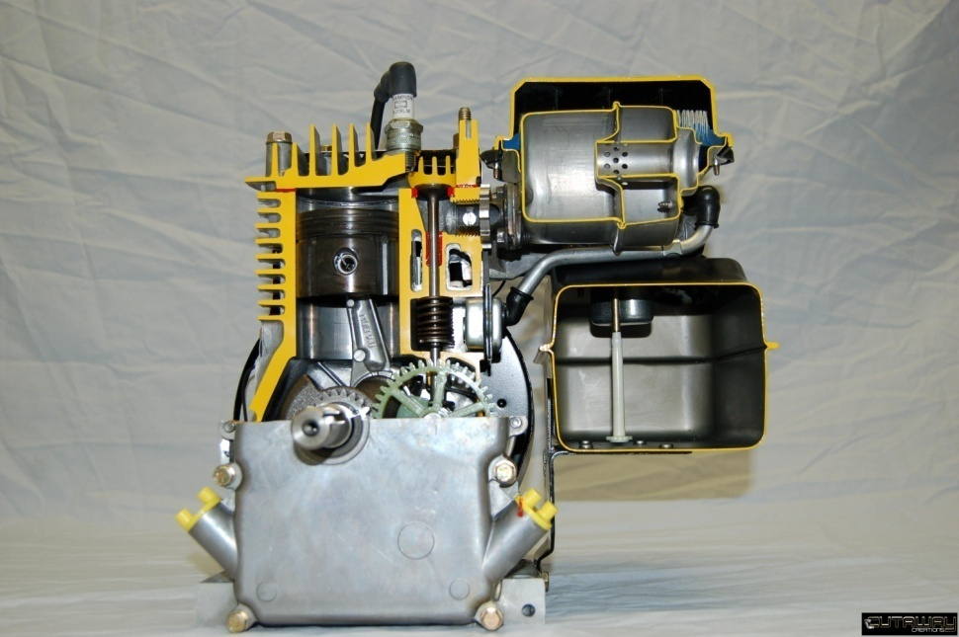

**Student Objectives**

After over-hauling this engine, you will be able to:

Understand the safety rules to follow when working around small gas engines.

Properly use a "compression tester" on a small engine.

Disassemble and re-assemble a small engine using the proper tools.

Properly remove a carburetor and its linkages from a small engine.

Properly disassemble the valve train assemblies in a valve-in- block engine design.

Remove and re-install the internal parts of a small gas engine.

***Before beginning this section of the module, you need to have successfully completed MEC1015 and workbooks 1 and 2 of this module. *It is vitally important that all safety precautions and instructions be followed while working on the engine. Any intentional abuse of safety practices or any dangerous behavior can result in a suspension from further activities.*\*\*\*

**Technical Terms**

Using the internet, shop manuals, service bulletins, write a brief definition for the following terms. Locate the part on the diagram on the following page and put the number of the part in the part number column. If the part is not shown, explain the purpose of the part.

/54

|  |  |  |
| --- | --- | --- |
| Part | No. | Description |
| engine piston | 41 | Goes up and down in the cylinder; has rings to seal and remove excess oil; receives pressure from burning gasses |
| connecting rod assembly | 45 | Connects piston to crank shaft |
| spark plug | 135 | Ignites fuel air mixture |
| piston rings | 42 | Seal gases in combustion chamber; remove excess oil from cylinder walls |
| engine valves | 125 & 126 | Control entry and exit of fuel/air mix and exhaust in to combustion chamber |
| cylinder head | 120 | Removable top of the combustion chamber |
| head gasket | 119 | Seals cylinder head to block |
| fuel tank supply valve | Not shown | Turns off fuel supply from tank |
| fuel tank, fuel lines | 300 & 290 | Store and carry fuel |
| air cleaner | 245 &/or 250 | Removes dirt and debris from air as it is pulled into the engine |
| carburetor | 380 | Mixes fuel and air; controls amount of fuel mixed with air |
| carburetor throttle shaft | Not shown | Shaft on which the throttle butterfly plate is attached |
| engine governor | Not shown | Controls the speed of the engine while under, and not under, load |
| engine muffler | 275 | Controls noise of engine gases leaving the exhaust port |
| flywheel | 90 | Creates electricity for spark; aids in cooling; provides momentum |
| magneto | 100 | Creates electricity with flywheel |
| one- way clutch (flywheel nut) | 92, 93, 285 | Holds flywheel on crankshaft; allows starter rope to disengage when running; allows pull start to work in one direction only |
| crankshaft | 30 | Receives power from piston and transfers reciprocal energy to rotational energy |
| electronic ignition | Not shown | Module which eliminates need for moving parts to deliver spark; often part of the magneto |
| valve cover | 174 | Covers the valve springs |
| valve spring | 150 | Keeps tension on valves to remain closed unless pushed open by action of camshaft |
| valve keeper | 151 | Connect valve spring to valve |
| engine cylinder wall | Not shown | Part of the block in which the piston moves |
| camshaft | 50 | Gear driven operator of the valves; timed with crankshaft to coordinate valve opening in relation to piston position |
| Lifters/tappets | 48 | Ride on cams of camshaft to lift valves |
| crankcase | Not shown | Part of engine block that houses internal units – crank, piston, oil slinger, camshaft, lifters, connecting rod |
| oil slinger/oil pump | 52 | Device which spreads/sprays oil; forces oil through galleries in the engine to aid in complete lubricating |

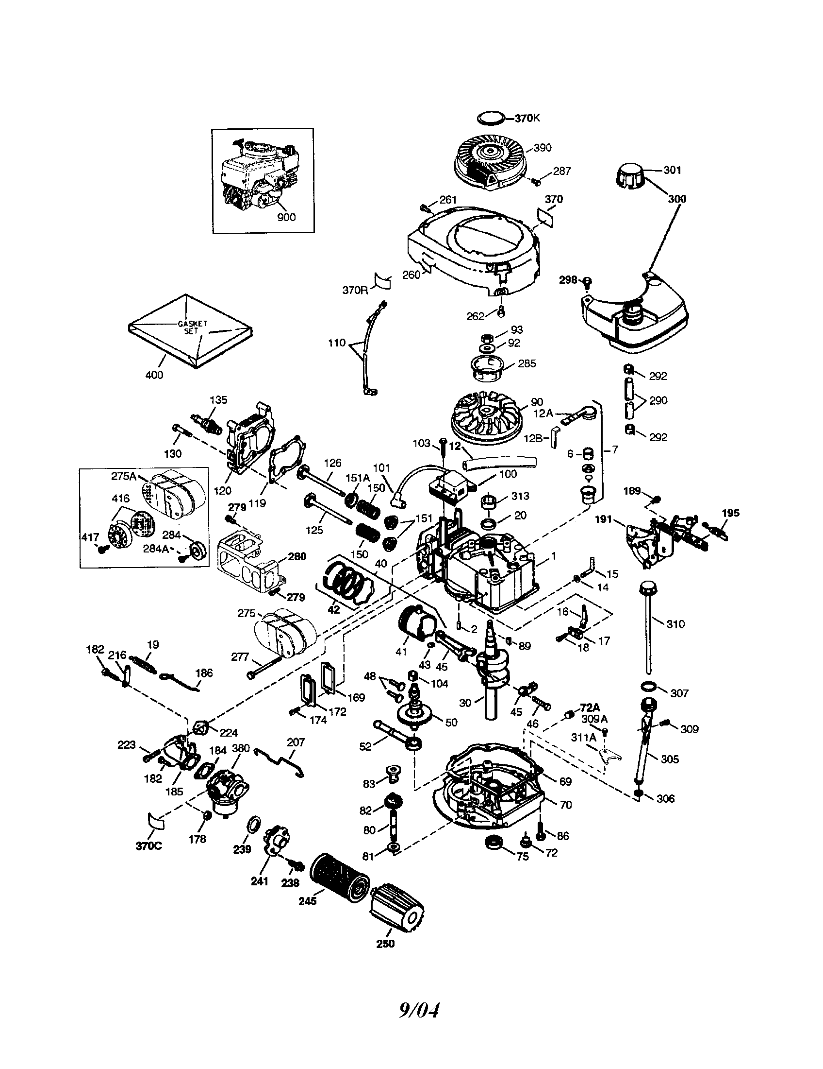

*The following assignments deal with the disassembly and reassembly of the engine. Read over the questions before you begin and try to keep them in mind as you work on the engine. A good practice is to quickly read the questions at the start of each class, answer the ones you can and keep the remainders in mind as you work.*

**Progress Checklist** – *This checklist needs to be checked/initialed by the instructor at the points indicated.*

|  |  |
| --- | --- |
| **Steps - Disassembly** | **🗸** |
| Inventory sheet of tools in student station completed |  |
| Remove fan shroud; identify flywheel, magnets, fins |  |
| Remove air cleaner; find element and determine if it is oil or paper |  |
| Explain fuel path |  |
| Drain gas into container |  |
| Remove spark plug; remove head – keep bolts organized |  |
| Trace path of electricity in engine |  |
| Remove carburetor; detach fuel line; detach linkages |  |
| Remove muffler |  |
| Drain the oil |  |
| Clean end of crank shaft; remove crank case bolts; remove crank case cover |  |
| Remove oil slinger, cam shaft, lifters |  |
| Remove valve cover |  |
| Remove valve spring retainers; remove valves, springs |  |
| Compare valves, springs |  |
| Remove connecting rod cap |  |
| Remove piston (remove ridge if needed) |  |
| Remove connecting rod wrist pin; reinsert retainer |  |
| Identify rings |  |
| Remove rings |  |
| Remove crank shaft |  |

The following questions deal with the disassembly and reassembly of the engine. Answer the questions in the space provided

***Disassembly***

1. Name 5 safety rules that should be followed when working around small gas engines.  
   - practice good housekeeping  
   - clean up any spills immediately  
   - properly dispose of oily rags  
   - ensure proper ventilation  
   - protect any open cuts  
   - watch out for hot components if motor has been run

/5

1. What specific information is found on your engine?  
   Model, serial number, type

/3

/1

/1

/1

/1

/2

/1

/2

/3

/1

/1

/1

1. What piece of equipment is your engine it designed to be used on?  
   likely a lawnmower
2. What should be removed first when disassembling a small gas engine?  
   gas
3. What is a fan shroud? Directs air over engine block  
     
   a) The shroud directs air that is being forced by which part of the engine? flywheel  
     
   b) What else is there on the engine that helps support cooling? How does it work?  
   fins on the block; the increased surface area gives more area from which to dissipate heat
4. Why is it important to note the location of any linkages or springs when removing a carburetor from a small engine?  
   if not put back together properly, the engine won’t function properly
5. Describe how to remove a fuel tank and fuel lines from a typical small engine.  
   empty gas; remove bolts holding tank to engine; disconnect hose connecting tank to carb
6. Explain how to use a compression tester on a small gas engine.  
   remove spark plug; insert tester in spark plug hole; turn engine over by hand
7. Name a method used to remove a flywheel from a small engine.  
   flywheel puller
8. Why should all parts and fasteners be organized during a small engine teardown?  
   so pieces aren’t lost; all pieces are more likely to be returned to proper spot
9. What type of damage can result if a small engine is operated with little or no oil in its crankcase?

Scoring of bearing surfaces; increased friction leading to chance of fire, melting of metal parts

1. What were the easiest parts to remove in your four-stroke /cycle small engine crankcase?  
   cam shaft; oil slinger; lifters (any 2 of the 3)

/2

/3

/1

/2

/1

/2

/1

1. What tools are usually required when removing the connecting rod from a small engine's crankshaft?  
   screwdriver or punch; hammer; wrench or socket
2. What is the orientation of the crankshaft in your engine? Likely vertical
3. What is a bearing? Can bearings have no moving parts?  
   a bearing is a surface or contact point between two moving parts; yes, they could be lubricated solid surfaces
4. What is the purpose of an oil slinger?  
   to spray oil around the interior of the crankcase
5. What problems can arise from having bad rings on a piston?  
   improper sealing; escaping gas pressure; excess oil consumption (any 2 of 3)
6. What could happen if an engine is reassembled without using any oil or lubricant?

The friction between parts could cause permanent damage  
  
  
  
  
  
***Occupational Connection Worksheet***

Complete an Occupational Connection Worksheet for this module, discuss it with your instructor and have them initial this book.

/89